**Report about conducted load test**

**Date:** 09/06/2022

**Author:** Vladyslav Kliucharov

**Application:** BlogEngine.NET version 3.2

**Environment:** Test Environment VirtualBox (Version 6.1.34 r150636 (Qt5.6.2))

**Test Environment configuration(RAM, CPU etc.):**

|  |  |
| --- | --- |
| **Processor** | 11th Gen Intel(R) Core(TM) i7-1185G7 @ 3.00GHz 3.00 GHz (4 core) |
| **RAM** | 8 GB |
| **Hard Disk** | 60 GB |
| **Operating System** | Windows 10 Enterprise (21H2) |

1. **Why such testing was conducted:**

The report is included two methods of testing:

1. Smoke testing - was conducted to verification that the crucial functions of a program can be run and executed in the main workflow

2. Load Testing - was conducted to define that the system behavior is expected under the average load

1. **Test script description:**

The features to be tested have been logically grouped to be covered of 1 script that were developed followed by load requirement analysis for the modules. The below table captures the features covered by the script

1. **Tests:**  
   **Test run preconditions:**

* CSV file with Credentials
* Warmup script was running before each test run
* Before each new test script run, the webserver was reloaded, the test executed in NON-GUI mode  
  **Load Model:**

|  |  |
| --- | --- |
| Maximum number of simultaneous users | 2 |
| Ramp-Up period | 20 |
| Test duration | 600 (sec.) |

1. **Short summary on conducted tests:**

Load testing showed that the system can works stable without any errors

1. **Detailed test results:**

The tests were running 2 times, and according to the load testing result, the system work correctly. The result was received by comparing of test results, which are shown on the graphics and table value (view below).

**Test Run #1**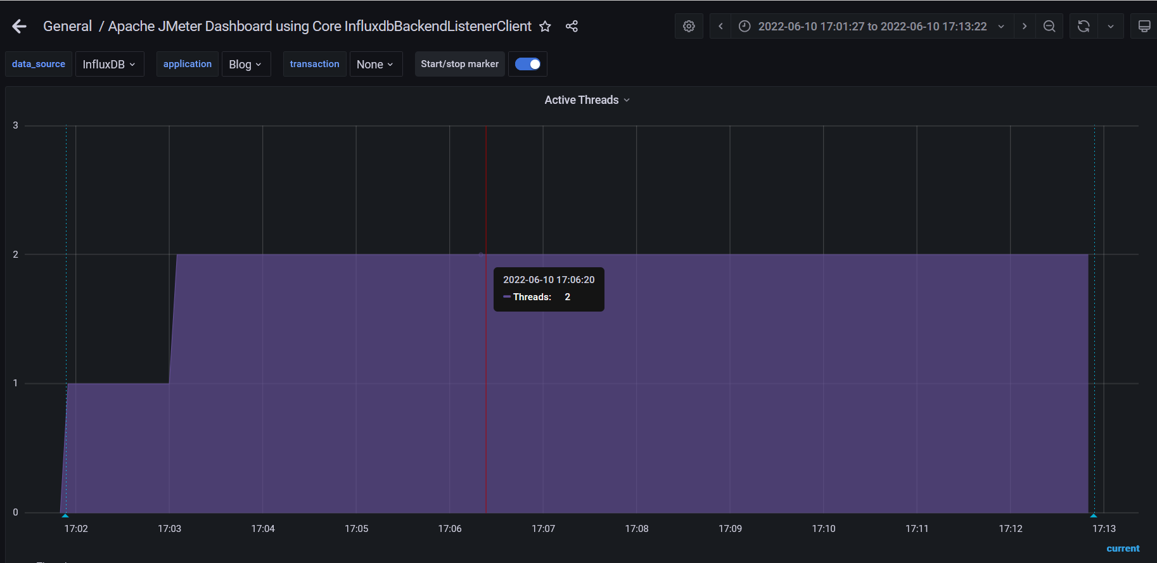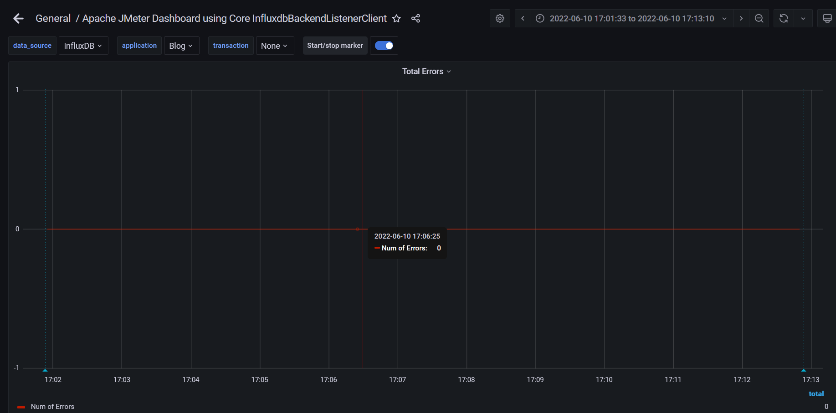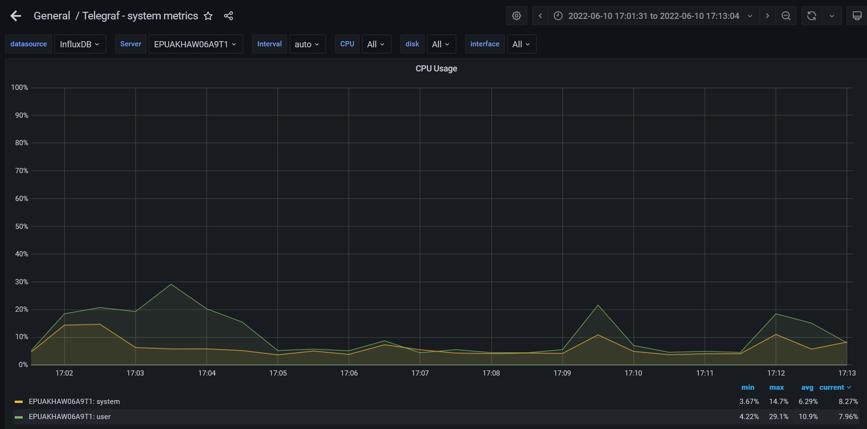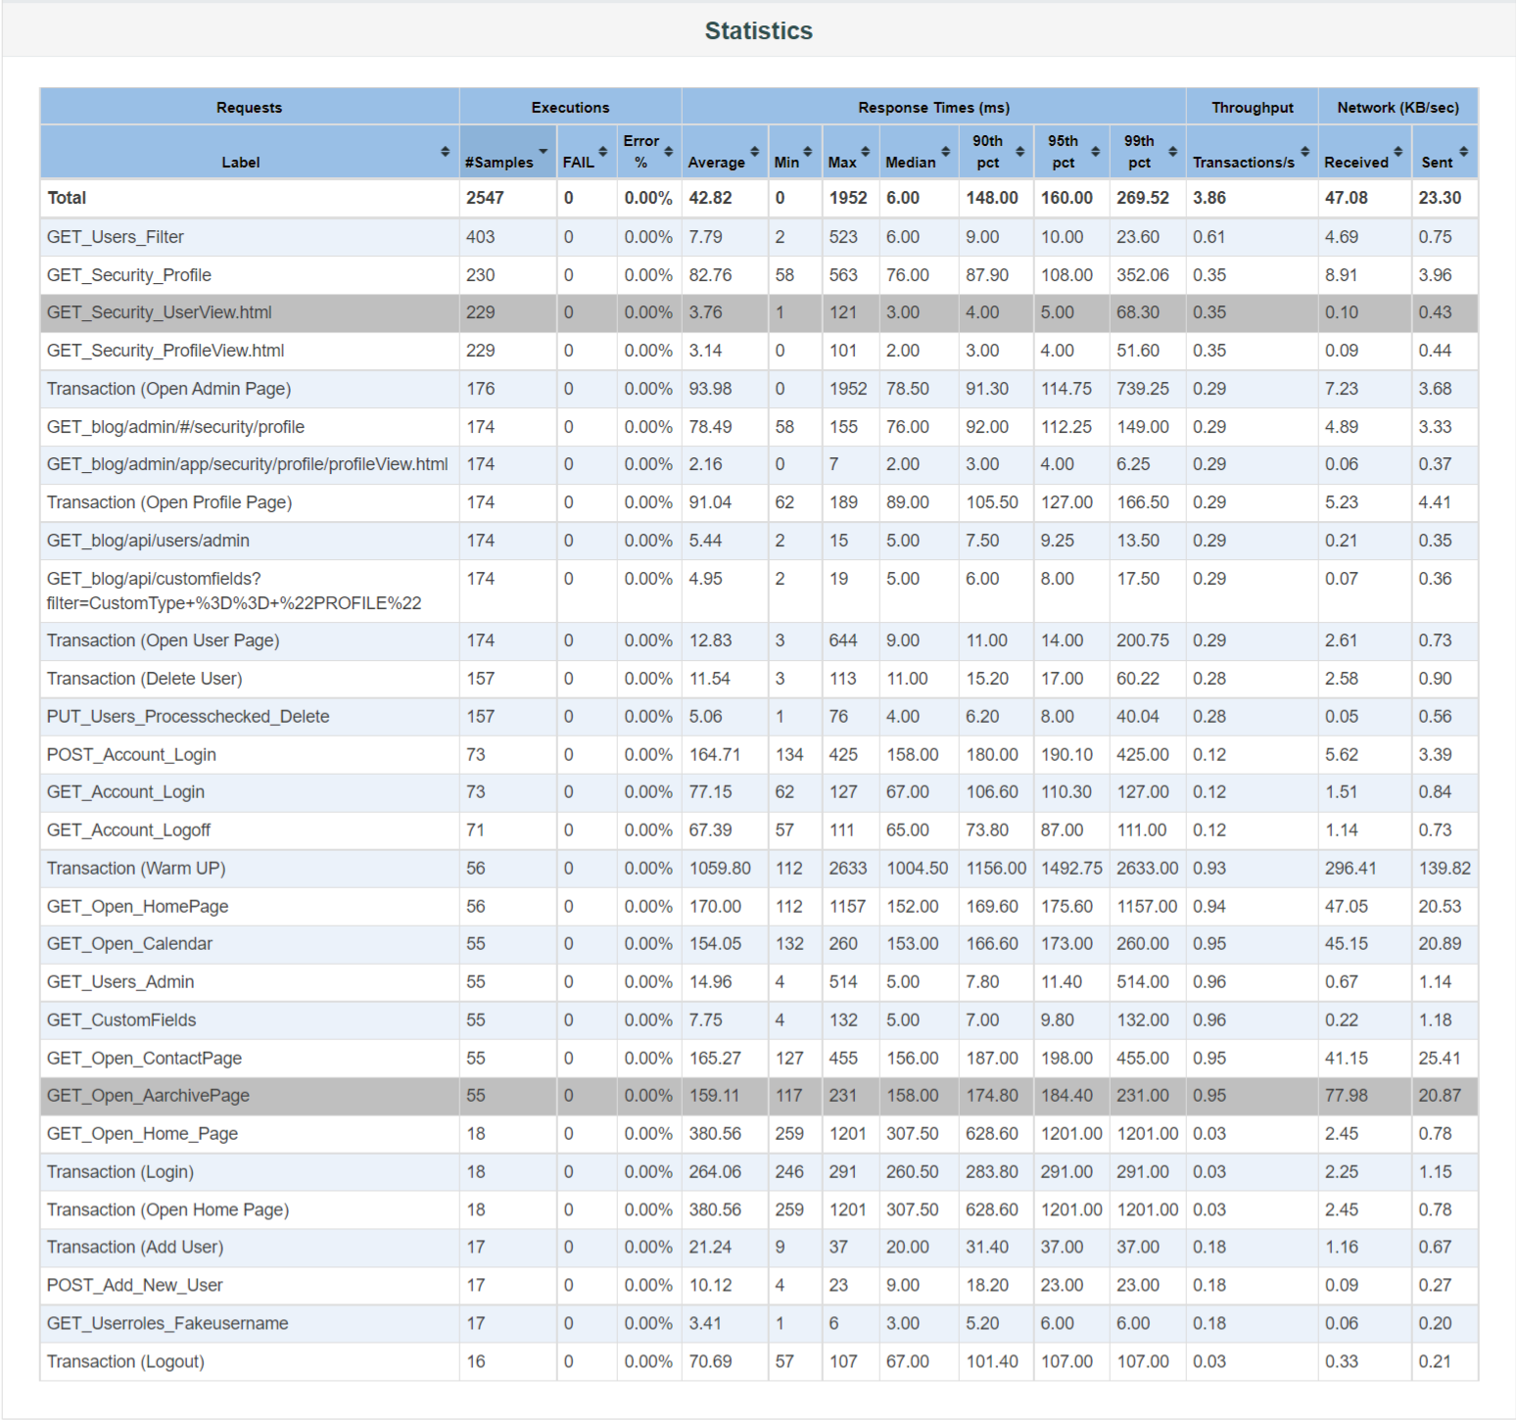

**Test Run #2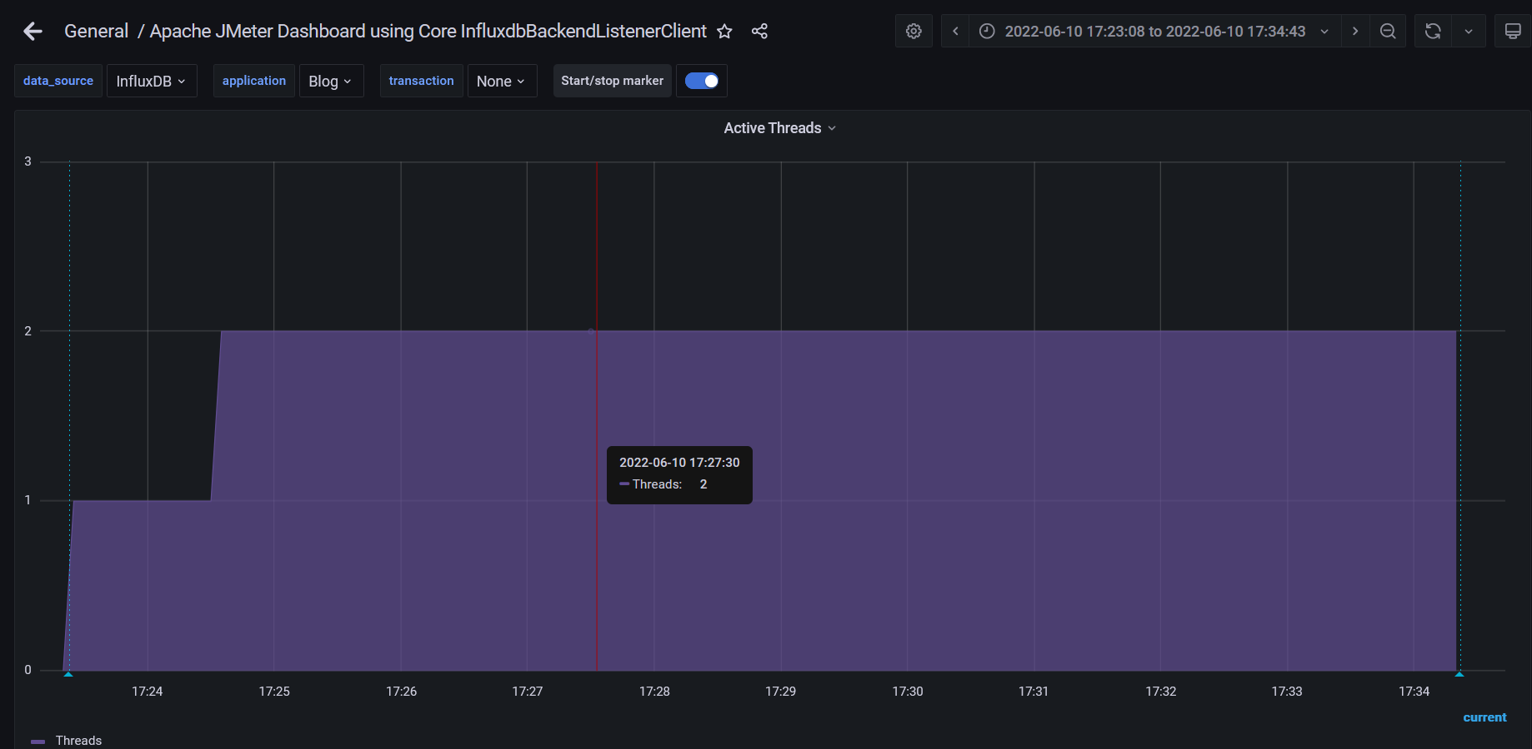**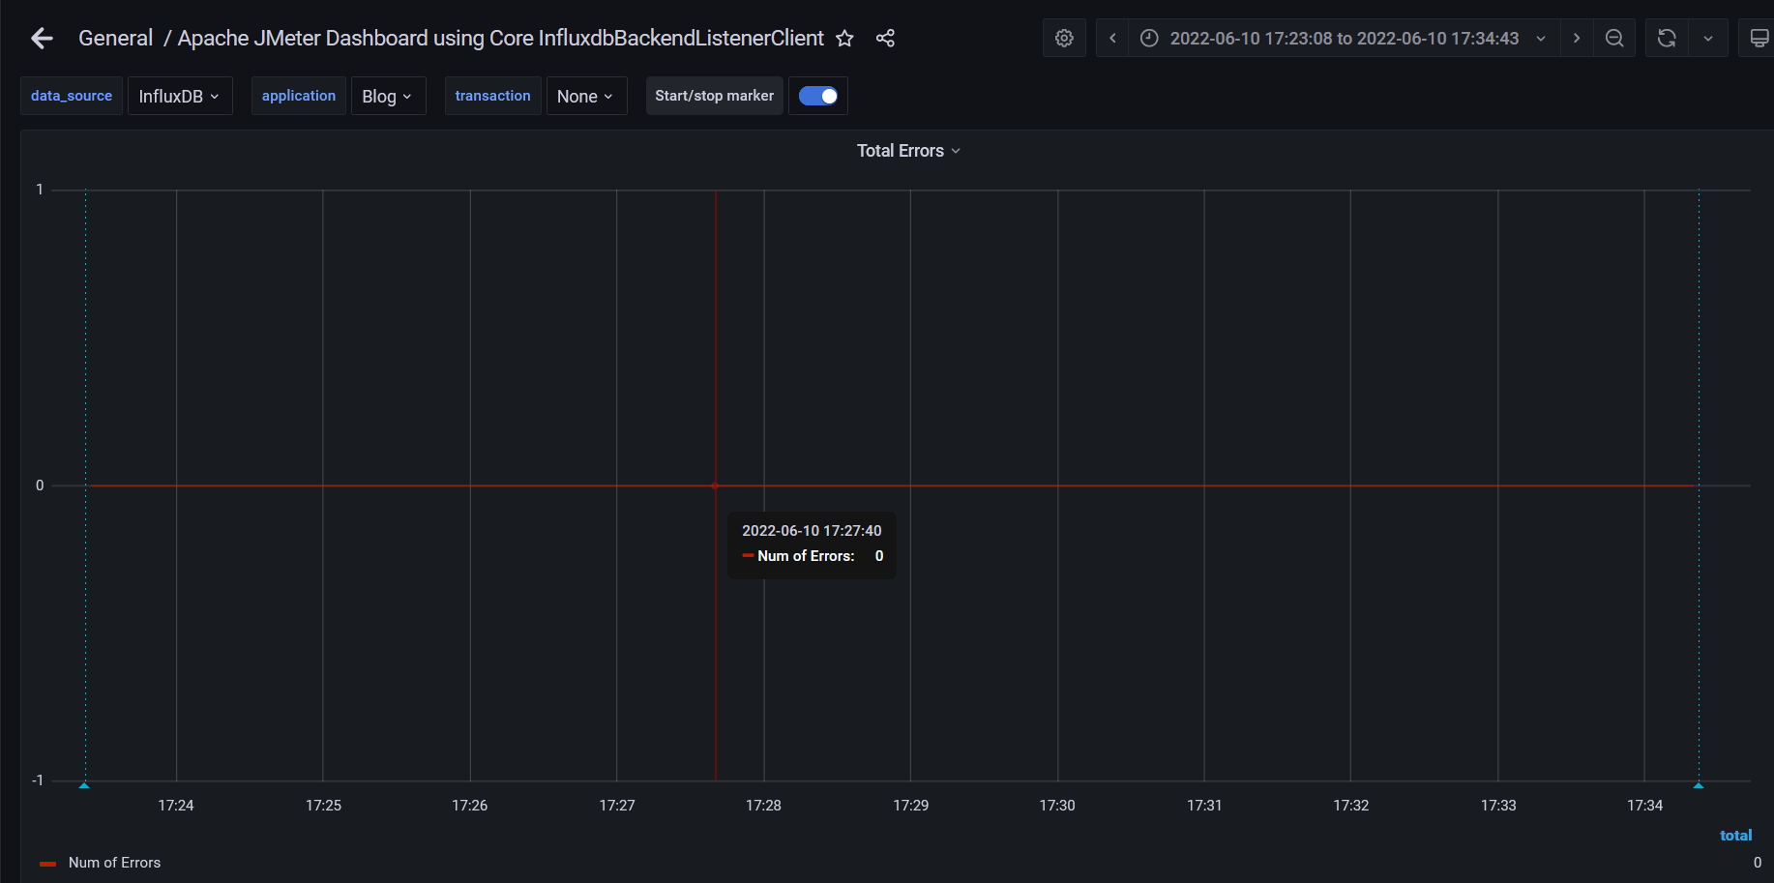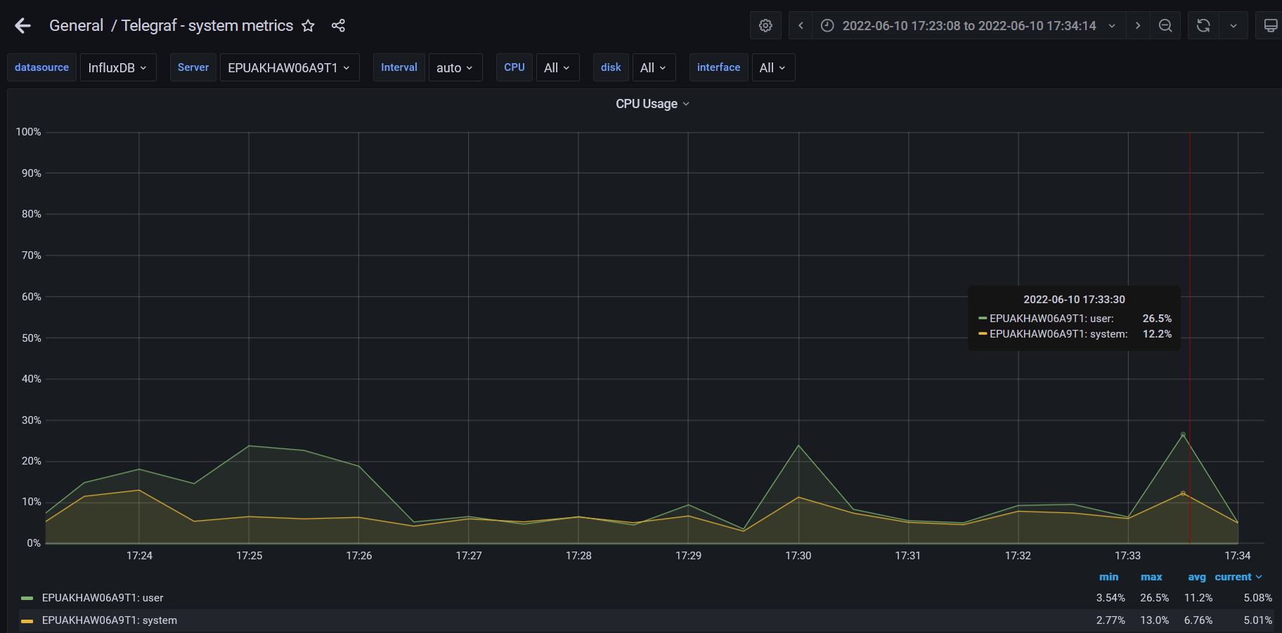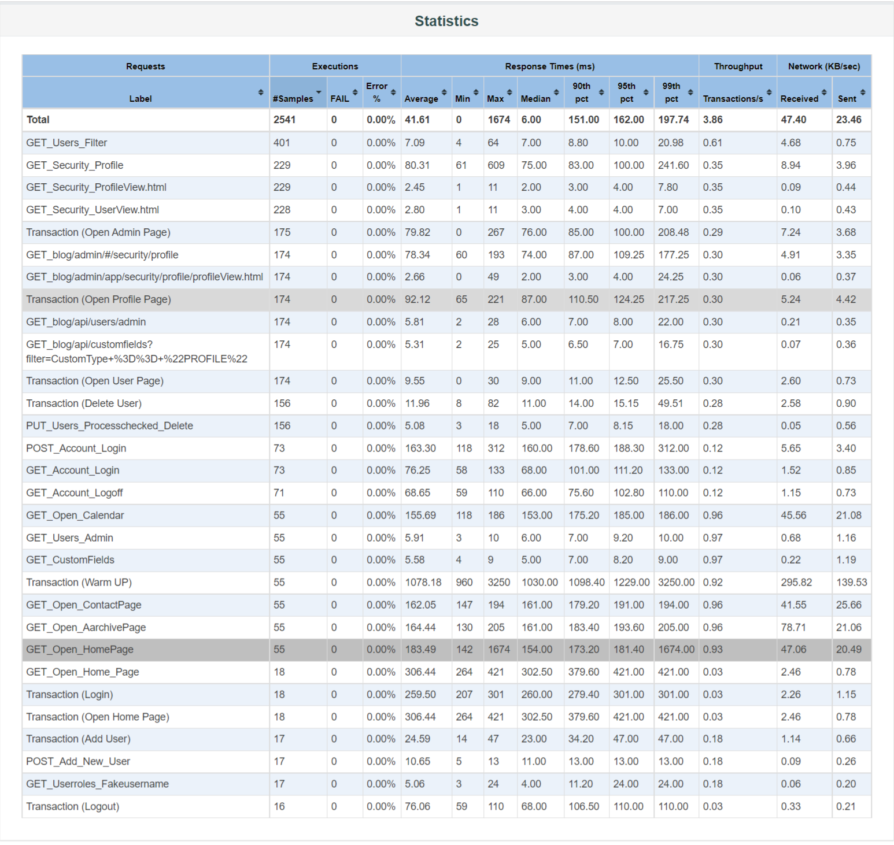

**Conclusion:**

Application behavior is a normal for two users, system work without any anomalies, CPU usage from 2 test results was approximately 8 %.